Unit testing HAS to be aligned with the software requirements. If your tests aren’t aligned with the software requirements, your functionality isn’t aligned with the requirements. I truly believe it is that simple. Sure, in a professional setting you can code your way through functionality and let some sort of generative AI examine what you built and produce tests around the intent of what you actually coded, but that doesn’t necessarily reach the same outcome as true test driven development or even proper unit testing written to the requirements. Unit tests are supposed to test that the software fulfills the requirements. It also protects the software from passing CI/CD pipelines if someone changes the code to no longer align with those original software requirements. It raises a big red flag that says, “There was a reason for this functionality, and you just broke it!”
Most of my unit tests are specifically designed to test that the requirements were met. Let’s investigate the ContactService and Contact POJO’s to analyze this a little further. The requirements for saving a Contact were that it had to have a unique ID, and 4 required fields, first name (up to 10 digits), last name (up to 10 digits, phone number (equal to 10 digits), and an address (less than 30 digits). The contact service would only add contacts with a unique id and be able to update and delete those contacts. Let’s see how the tests test and validate this functionality:
We first have to test the ‘happy path.” Therefore, if we pass valid parameters to our add method it creates a contact. If it succeeded, a contact would be created and we can ensure that the Contact has the valid parameters we passed to it, as seen in the below test.
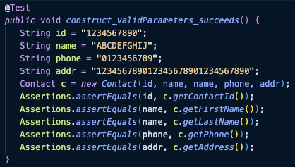
These fields are also required fields. Thus, they cannot be empty fields or null. You can’t pass in a bunch of spaces, or no value at all. We can see that in our tests like construct_emptyFirstName_throws, which we assert that an invalid argument exception is thrown if we pass a blank name. We also have a test that tests each parameter for nulls.
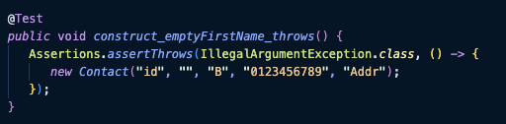
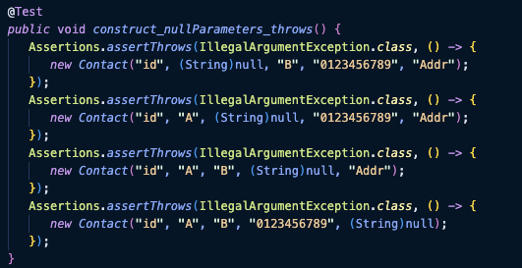
Finally, each has a length requirement, So if these fields violate that length requirement It would also throw an exception which can be seen in the construct_(insert field name)TooLong_throws tests, which test each parameter with too many characters and ensures it throws an exception.
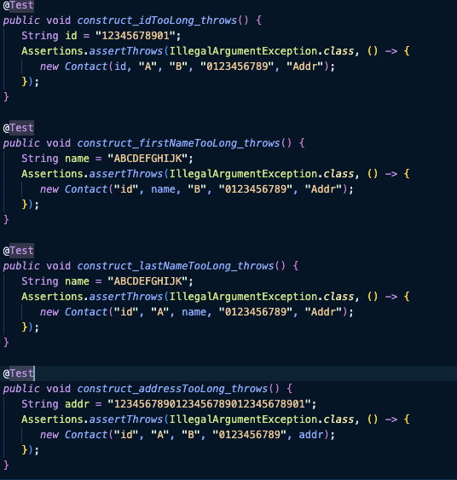
The contact service also needs to be able to add, update and delete contacts with unique Ids. First the happy path, we give it valid values, and ensure we can get that added contact.
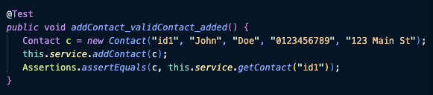
Testing that deleting actually deletes a contact
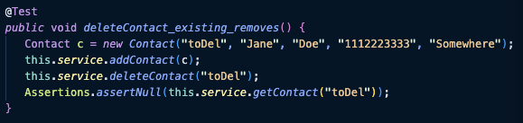
Testing that we actually updated the values of an existing contact by adding a contact, calling the updater with new values, getting that contact by its ID, then ensuring the values equal the new values.
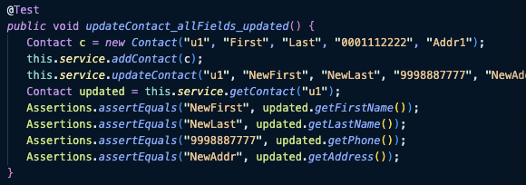
This is how my testing aligns with the requirements, Yes there are additional tests to ensure certain exceptions are thrown, that the methods are null safe, and that other more programming coverage to protect the codebase from silly mistakes. However, the lump some of the testing specifically targets the software requirements. Furthermore, I know that the overall quality of my unit tests is high because I had a higher than 90% code coverage. This means that my tests are covering over 90% of the code’s overall functionality, guard clauses, etc. Thus, if a different developer were to change the code base in any way that doesn’t align with the ORIGINAL intent, these tests would fail. Therefor, the tests would need to realign with any changed requirements, or that developer would have to rework the solution to align with the requirements.
As far as ensuring that code is technically sound I believe I showed it in above examples. One key test is the contacts_nullParameters_throws pictured above where any null parameter results in an IllegalArgumentException by using the AssertThrows to capture that to pass the test a null argument should throw an exception. Nulls have their uses. It’s completely normal in some database schemas to use null values. Nulls can also cause a null pointer exception that shuts down the entire system. Thus, as a good technical programming practice we either have to protect against nulls completely, or program for nulls as a standard (and create business logic surrounding null values). There really is not an in between, as it can create difficult to troubleshoot bugs if it makes its way into production. I didn’t have any performance tests or otherwise to prove or ensure my code was efficient. Nor, is there any recursion or loops in the code. Thus, by its nature the code is efficient as possible. I even included equals and hashcode methods on all objects to ensure the HashMaps ran as efficiently as possible. Had there been requirements surrounding efficiency, such as, “api calls should be under 6 seconds” then there would be real reasons to test the efficiency of the underlying processes, and integration tests to test the overall efficiency from front to back.
There are a few testing techniques I believe I employed while completing the Project. Testing techniques we’ve discussed can be divided into two main categories, static and dynamic. Static testing techniques include inspections, peer reviews, walkthroughs, etc. Dynamic testing includes automated unit testing, assertions, etc. In the project the static testing technique I used the most was reviews. Specifically, inspections of the requirements. Each module we were given the requirements for the next service. I had to carefully inspect those requirements to ensure completeness, accuracy, and ensure the requirements covered testable rules.
For example I for the appointment service the requirements stated that I needed to create an Appointment object and AppointmentService class. Furthermore, like the contact service and contact object’s requirements about required fields and unique IDs, It stated that dates of appointments couldn’t be before the current date, the id had to be unique and immutable, and the description is required. There were also length requirements. By inspecting the requirements, I was able to obtain the information I needed to accurately complete the service.
I also used Dynamic testing techniques. By definition, dynamic testing are tests executing the code. Unit testing is the first, and primary, of these techniques. Our goal is to test each unit of code (a method for example) to ensure that it meets specific requirements outline in the requirements document. Let’s continue to use the appointment service as our new example. There was specific requirements about the length of description and IDs as well as them being required fields. Below is a screenshot of some unit tests that meet some of those requirements:
Before each test we create a valid appointment:
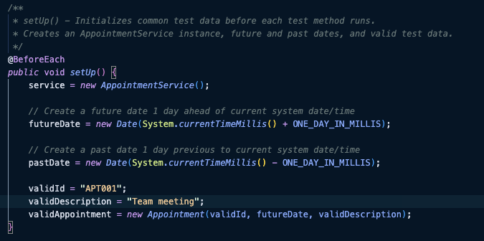
I created a test that asserts that a valid appointment can be added and found in the in-memory storage:
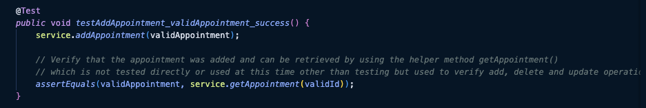
Then another test on the appointment object (where the length validation occurs) that asserts it prevents a really long description from saving:
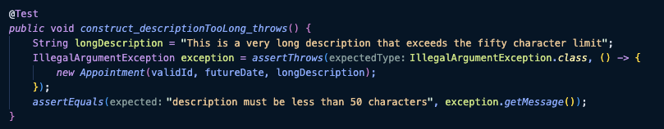
There are other testing techniques that I didn’t employ in the project. Notably, dynamic testing techniques like integration, system, performance, security testing, load/stress testing, etc. Since we don’t have integrations, a functional api, and other real world architecture. these tests aren’t necessary. One thing that can be implemented would be performance testing. As I touched on before, I have no tests ENSURING efficiency. I could have used some techniques like taking the time to create a test that tests how long it takes to add an appointment, contact, or task by comparing the milliseconds of system time at the start and the end and ensuring it was below a certain number. Static testing that wasn’t employed was peer reviews for example, The requirements were already written, and a peer review was not requested of me, for one example.
There are many uses for all these testing techniques discussed. I work building a large enterprise software product for a government entity. There is a use case for every one of these testing techniques, and believe me most of these techniques are being utilized. For example, when we create an integration with another service we go through integration testing with that service to ensure we are connecting to the service properly, pulling the correct properties, etc. load and stress testing of microservices are performed to ensure the microservice can scale with increased load and the services that it doesn’t go down during load. These stress tests are typically only performed on critical services, like document services, and database related services to ensure that the legacy systems can handle the load of the new service. Unit testing ensures code meets requirements for specific functionality, and test coverage requirements set by the business. Every testing ensures we deliver what we promised and we don’t get surprises effecting millions of users and the claimant’s claims aren’t delayed further than necessary.
Now that I’ve summarized my unit testing approach and reflected on the testing techniques, I’d like to spend the remaining paragraphs reflecting on my mindset throughout this course and the project. It can often feel like developers and testers are in an ongoing war. This is especially true in some industries, like the video game industry, where traditional waterfall project management is present or testing is done separate from the developers. Also in companies where testers are seen as ‘lower than’ developers, and it is a difficult path to move up from a tester to a developer. I’ll admit, I’ve seen some developers bully testers into passing their code because, “that just happens in this environment because x, y and z.” I have also seen testers avoid conflict and not report errors during manual testing due to social constructs or behaviors. It’s a weird rea we work in.
It was hard to take the role of a tester as my only experience with testers are manually testers. I write my unit tests. That being said, to what point did I employ caution? A LOT more than I normally would have. If testers employ the attitude of finding problems is their job, I feared a professor teaching testing would do so exponentially. Where null safety and exception handling is something I employ fairly regularly, I did so with vigorous intent as to make it as cautious and protected of a code base as possible. I didn’t really see the code as too complex nor having too many interrelationships however, It was really a simple service layer and the underlying pojo. I’m not sure there was much to appreciate. However, due to the design I was required to decide where what validation was necessary where. I landed on the POJO doing the field level validation, and the service doing service validation. Thus the testing for length, empty fields, nulls, etc. landed in the POJO as illustrated above by the ContactTest screenshots, and the service tested that only one ID could be persisted, that you could add, delete, etc. This separation of concerns of testing was brought about by the interrelationship of the code.
Bias is absolutely present when I’m testing my own code. When I develop I tend to cast a pretty small net on what I test to ensure I’ve met the ACs. Yea, Yea, I know it’s not the best. But I develop in a very exploratory way. I work fast, break things, fix them, and push to a PR. I then provide suggestions to my tester on things I’ve done to test it that worked on my local environment (the happy path and some outliers), and then suggest things that I think about later that could be exceptional outliers that are worth testing. She aligns those with what she came up with for test cases and creates a broader net. However, it is easy to code to the 90% of use cases and only test half of that just because you are on a time crunch. That is why I cast the small net though. I do exactly that, then I pass it to my tester after I have something that covers the outliers, and covers the ACs of what it is supposed to do. It’s her job to have a finer eye, try different data, etc. and find the “weird” behavior that I couldn’t have possibly accounted for because the ACs weren’t explicit enough. One example recently was that I was coding a type of object that is a sub object/card of a larger period of service. I had noticed that the service call always failed with one particular type of period as the parent object. The child objects code couldn’t account for, and match up the parent object because of all the data transformations that had occurred for the display when the form was trying to match it up to the raw response data. It was a bug that existed for months because in my original implementation I hadn’t tested the ‘Other’ types of branches. It didn’t even occur to me to test it. This bias almost resulted in a production bug, and would have if we deployed on time. Luckily I was able to slip it in after UAT testing had found other bugs before the business ever noticed.
The above example is EXACTLY why it is important to commit to a disciplined, methodical approach to development/testing and commit to quality as a software engineer. It was my and other developer’s laziness or lack of disciplined methodology that has resulted in us deploying later than we would have liked. Almost a sprint or two behind our deployment schedule at this point. The lack of guard clauses, little bugs like I described above, and more have resulted in red banner errors, integration issues and more due to silly mistakes. It’s just corner cutting, a lack of try catch blocks performing safe handling and return of other data, and more that has resulted in show stopping defects. In the future I’ve learned that it is important to start with the outliers, and weird stuff. Will it ever happen? Idk, maybe not. Does it add overhead with 3 guard clauses and if blocks? Yea, some negligible performance overhead. Is it ultimately making the code base more secure and protecting the data? Absolutely.
My major takeaway from this course has been the following. Whenever I’m starting a method at each layer I will first start with my guard clauses. Any method will at least have one if statement it needs to prevent some sort of exception, especially if you truly are following the principles of modularity and reusability. Next, I will make sure to at least employ SOME level of test-driven development. I will write a test for the happy path, and the more explicit ACs of the user story by hand to ensure they are meaningful and explicitly written to the requirements. Then as I code, I can ensure each AC is met, and the code completes the requirements it set out to. By compiling and running my code as I believe I have completed that test. I will still use generative AI as it is a company mandate at this point to assist one’s development and speed it up. Most of my tests surrounding null safety, outliers like empty strings, etc. can be written by AI to double check my work. However, I think implementing some TDD principles and starting with my guard clauses/try/catch every time will reduce the amount of technical debt for the project.

